If you are going to be away next two weeks, we need to get the equilibrium calculations done now, so we can start kinetic in the fall.

As a start, you should--in environment of your choice (MATLAB, Python)--implement the NASA coefficients for the species we are interested in for hydrogen (H2, H, H+) and argon (Ar, Ar+). You'll need fits for electrons as well, but you'll see how NASA CEA handles the electrons is to set the enthalpy of formation to zero and include the enthalpy of ionization into the species that is ionized.

The source of this data is here:

McBride, B.J., Zehe, M.J., and Gordon, S., “NASA Glenn Coefficients for Calculating Thermodynamic Properties of Individual Species,” NASA TP 2002-211556, Glenn Research Center, Cleveland, Ohio. https://ntrs.nasa.gov/api/citations/20020085330/downloads/20020085330.pdf

For hydrogen, I've attached the relevant data at a .txt file here.

For argon, you'll need to extract that data from the NASA report above.

The only data you should use from NASA is enthalpy of formation and the polynomials that are fit to c_p for each species.

Once you have these implemented, generate a table of values that you can compare to may table here. For example, for hydrogen, your function should generate values identical to these:

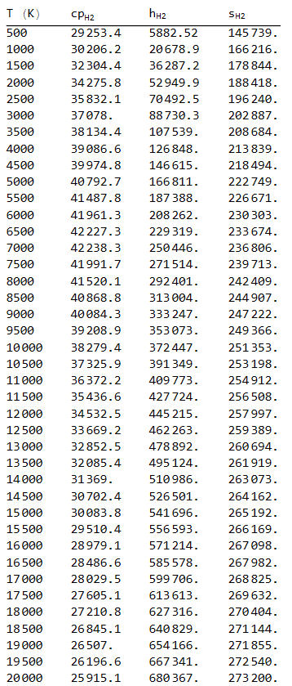

(To be clear, this table is for diatomic hydrogen (H2), but you should be able to generate similar tables for H, H+, Ar, Ar+, etc.)

Also, note that "s" here is not entropy as a function of temperature and pressure, but just the temperature dependent part of entropy. In Moran & Shapiro and in the NASA documentation (McBride, Zehe, Gordon), they call this s^o.

Now that you have the NASA polynomials working to give c_p(T), h(T), and s0(T), the next step is to generate functions for s(T,p) and Gibbs function g(T,p). Note all these should have a bar on top, because we are working on a "per kmol" basis. For entropy and Gibbs, the value for an ideal gas depends on temperature and pressure. You can find the appropriate expressions for entropy in Moran & Shapiro ( Eq. 6.20b ), and then Gibbs is just "h - T s", but be sure your "h" includes enthalpy of formation!

Also, good to start paying attention to that fact that the pressure to use is the partial pressure of the particular component, since soon we are now looking at mixtures. This is explained in Moran & Shapiro Section 14.1.2 "Evaluating Chemical Potentials."

As a test, you should make a table of Gibbs function (per kmol) for diatomic hydrogen and compare to my values here:

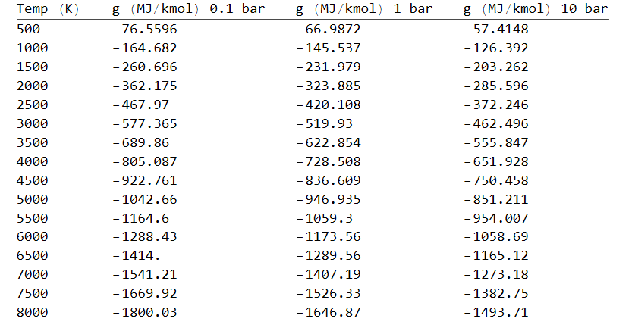

I made three columns: Gibbs g (in MJ/kmol) at 0.1 bar, 1 bar, and 10 bar.

Once you have that working, we can start to have some fun:

Let's load one kmol of H2 into a piston/cylinder. We'll put mass on the the piston so it always applies 1 bar (or 0.1 bar or 10 bar) of pressure and put the cylinder in a heater at 4000 K. The hydrogen will start to dissociate at this pressure, but the pressure and temperature are fixed.

Well call the degree of dissociation "x", so the mixture in the cylinder will be:

(1-x) H2 + 2x H

So, if x = 0, there is no dissociation and we just have the original kmol of diatomic H2. If x = 1, it has completely dissociated into two kmols of atomic hydrogen. We can plot the Gibbs function of the mixture by multipling by the number of moles of each that we have:

G_mix = (1-x) * g_H2 + 2 x * g_H

If we plot this G of the mixture as a function of x, here's what we get: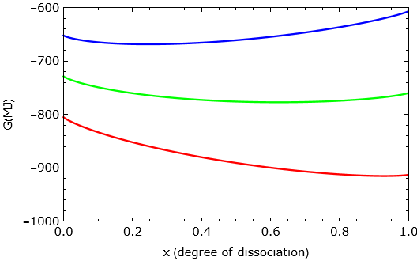

Here, green is at 1 bar, red is at 0.1 bar, and blue is at 10 bar. Note each curve has a minimum point: This is where the mixture will end up in each case! The system will evolve in a way to minimize the Gibbs function, and will "bottom out" when the Gibbs is at its minimum. This is when it reaches equilibrium!

See if you can make a plot like this.

Did you get issue with the Gibbs function resolved? You need to take into account the relative number of moles (or mole fractions).

Here's how I do it in Mathematica: